**Final Project CS619, Spring 2019**

**Project Name: Library Information System**

**Prototype Phase (Assignment)**

You are required to build a database application and perform the following tasks:

1. Install SQL Server any version.
2. Create a database in SQL Server Named as “bookStore”.
3. Create a table named as “book” which contains the following columns and its possible type.

|  |  |
| --- | --- |
| **Column Name** | **Type** |
| book_ID | Varchar(50) |
| book_Name | Varchar(50) |
| book_Author | Varchar(50) |
| book_Description | Varchar(50) |
| edition | Int(10) (optional) |

1. Create a Form or GUI in C#.Net/ VB.Net (Or some other language as per your choice). The form should have fields for adding book. Connect or link this Form with database “bookstore”.
2. The GUI/ Form should have the following buttons with functions:

**Insert:** Enters new book in database table (book)

**Update:** Updates book information.

**Search:** Searches a specific book.

**Delete:** Deletes the record of a particular book.

Sample screen shot of the GUI/ Form:

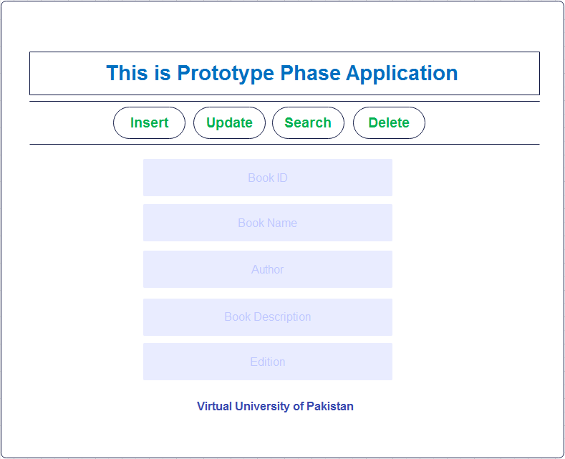

1. Submit your solution through LMS against Prototype phase.

**Note: You need to complete all the given tasks (1 to 6). In case of any doubt, let me know through email (**[**m.luqman@vu.edu.pk**](mailto:m.luqman@vu.edu.pk)**) or Skype Name (mluqman.vu) for help.**

**Good Luck!**